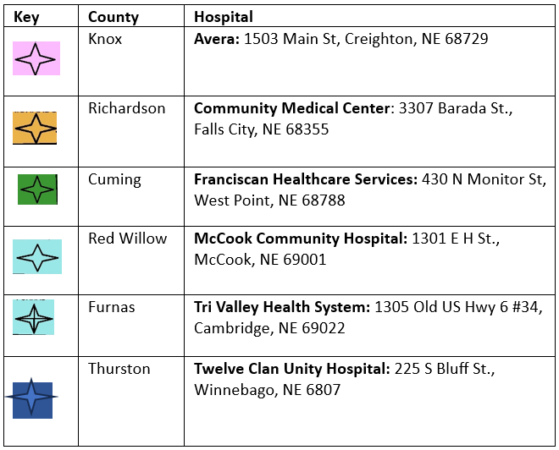
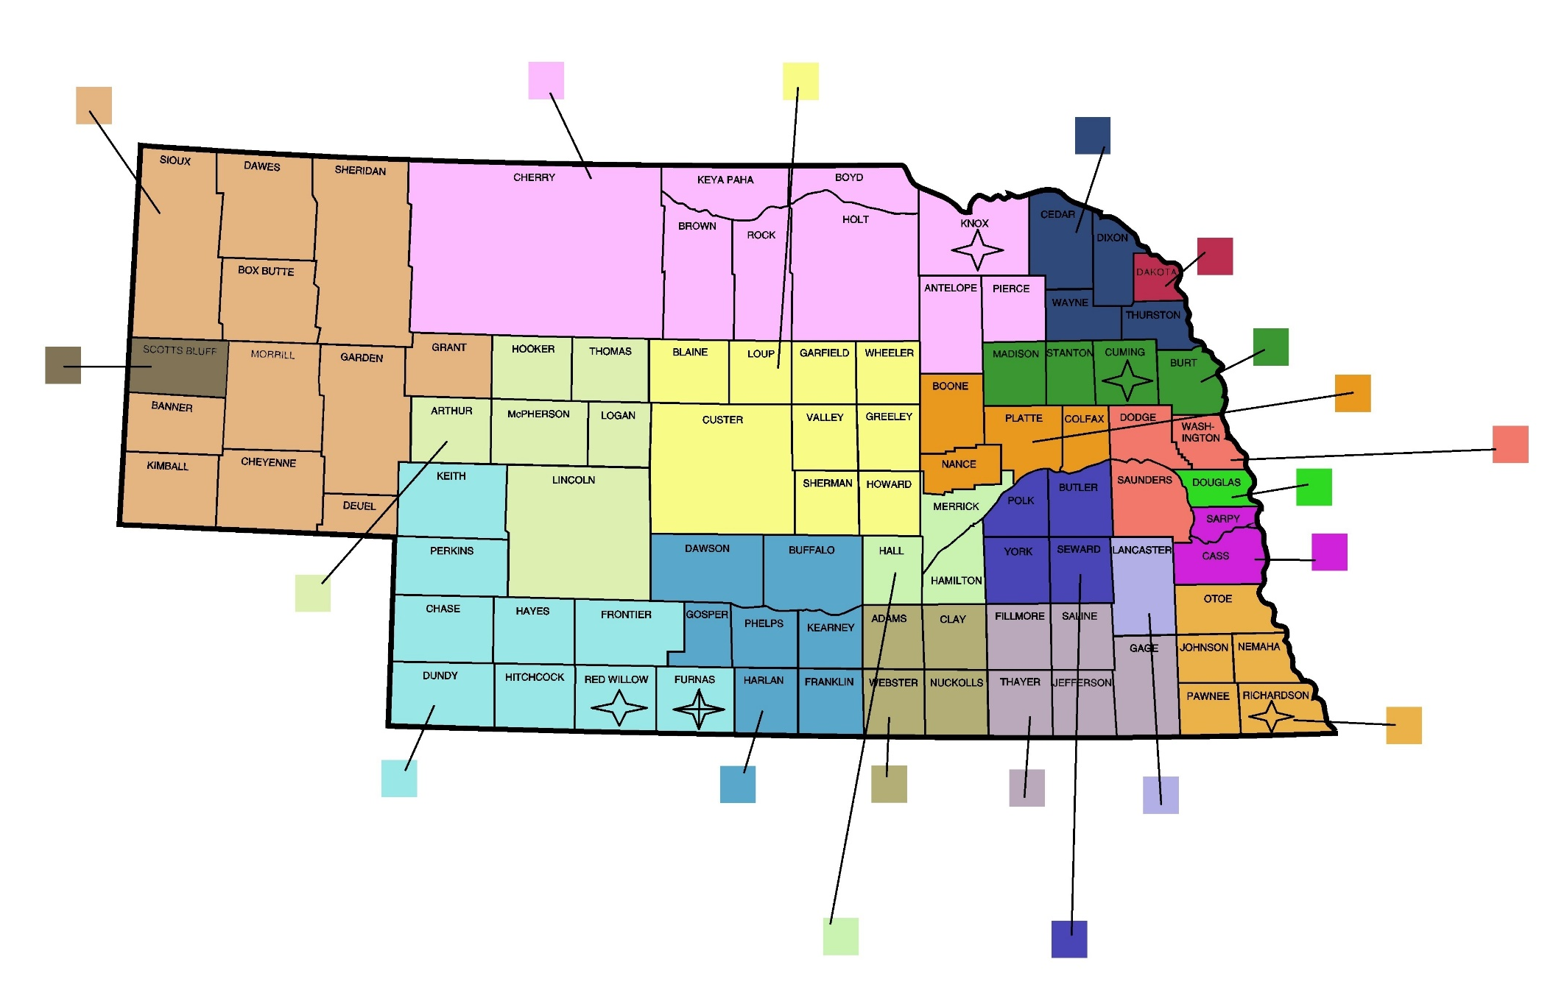
Three Rivers
Douglass
Southeast District
North Central District
Loup Basin
Sarpy Cass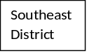
North East
Dakota
Elkhorn Logan Valley
East Central District
Landcaster
Four Corners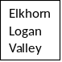
Public Health Solutions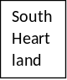
Central
South Heartland
Southwest
Two Rivers
West Central District
Scotts Bluff
Panhandle
Health Districts Names by color
Our Critical Access Hospitals In The State of Nebraska

