Lung Cancer Incidence in Kansas, 2023
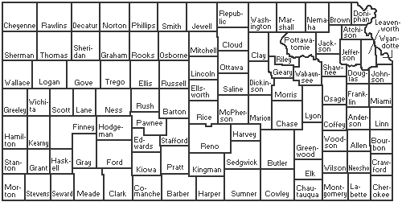
5.6
6.9
7.5
7.3
9.7
6.8
6.0
5.7
5.5
6.7
5.6
4.6
5.3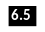
4.2
4.5
5.6
6.4
6.6
7.8
5.9
6.9
5.2
6.4
5.4
5.1
4.6
4.6
5.7
5.8
5.6
4.0
5.5
5.2 Geary
5.6
6.1
6.7
5.9
6.5
6.7
5.3
6.4
Douglas
4.8
5.8
Ells-13.3
Worth
Anderson
5.0
4.9
5.4
5.9
4.9
7.6
7.3
5.8
7.6
6.6
6.5
5.9
4.9
4.7
4.5
4.2
5.1
4.5
5.6
4.3
5.0
6.1
4.0
4.5
5.8
6.2
4.9
5.2
6.9
4.4
5.6
5.5
4.4
4.3
4.0
6.2
5.4
6.6
Legend: Incidence Groups by Color
No Data
4.0-4.4 | 5.5-5.9 | 7.0-7.8
4.5-4.9 | 6.0-6.4 | 9.7
5.0-5.4 | 6.5-6.9 | 13.3
Source: HQUIP intern (Kayla)

